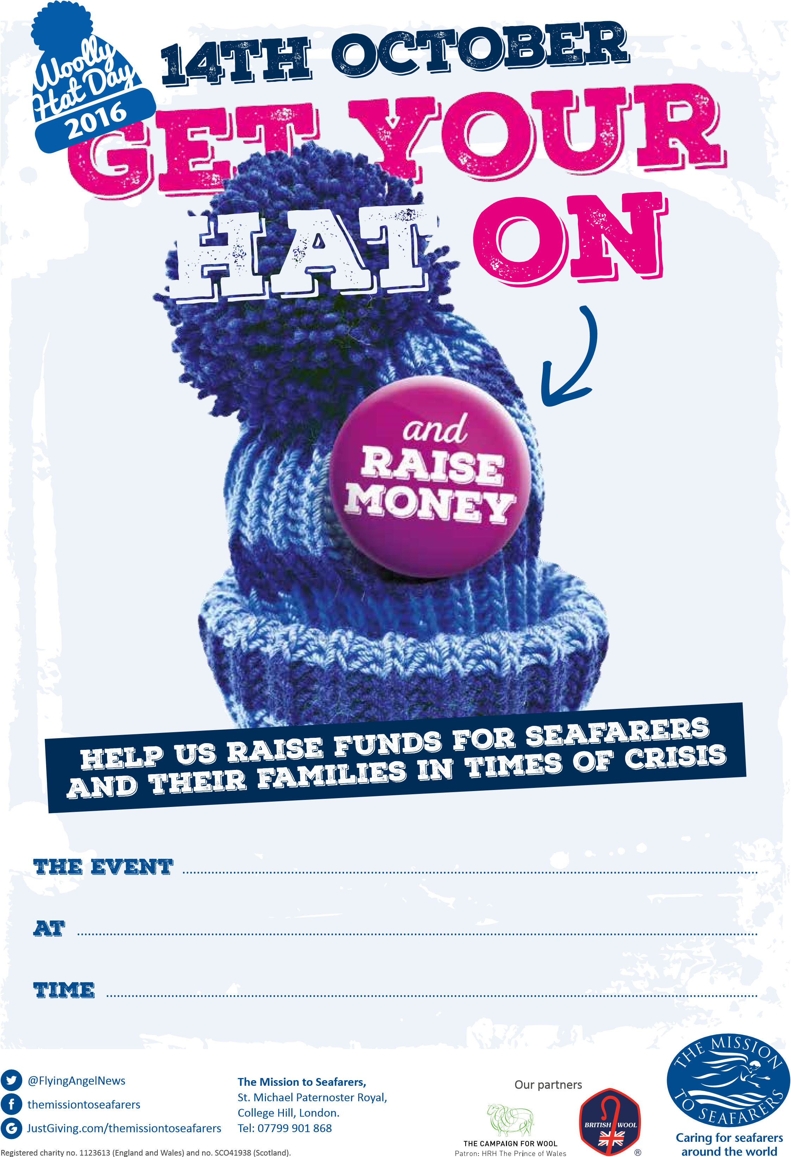

**10 am – 12.00 noon**

**16th OCTOBER 2021**

**St Nicholas Church, Harwich**

**16th OCTOBER**

**2021**